STAR
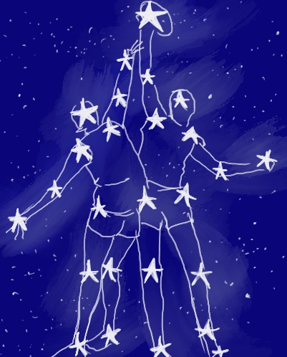
FOOTBALLER

By Furphies at Collins

Parameters

Parameters Form
Team Details
STATE: WA
DIVISION: Open (Required word count 7000 – 10000 words)
SCHOOL/GROUP: Furphies at Collins
TEAM NAME: Furphies at Collins
TEAM ID: 79
Parameters and random words
Parameters
Primary character 1 Football Player
Primary character 2 Astronomer
Non-human character Chalkboard
Setting Antique Shop
Issue Failed Test
Random words
Event, crisp, elastic, clumsy, bright
Authors and Illustrators
Ricky Arnold (Illustrator)
In Chapter order
Jen Banyard
Janine Fisher-Lee
Chris Oakeley
Amy Bell
Bronwen Channon
Danette Isgar
Roslyn Fairless

Copyright

Published by Furphies at Collins
Tom Collins House, Swanbourne WA 6010.

Copyright © 2026, Furphies at Collins

All rights reserved. This book is copyright. Apart from any fair dealing for the purposes of private study, research, criticism or review, as permitted under Copyright Act, no part may be reproduced by any process without written permission. Enquires should be made to the publisher.

Acknowledgements
Furphies at Collins would like to acknowledge the Traditional Custodians of the land on which this book was created, the Whadjuk people of the Noongar nation, and the Traditional Custodians of the many lands on which this book will be read, paying our respects to Elders past and present.
Furphies at Collins also sincerely thanks our kind-hearted supporters, including FAWWA.
We dedicate this book to the players and supporters who make Australian Rules football the legend it is!
And we send our warmest wishes to you, dear reader, as you read our cosmic tale of reaching for the stars.

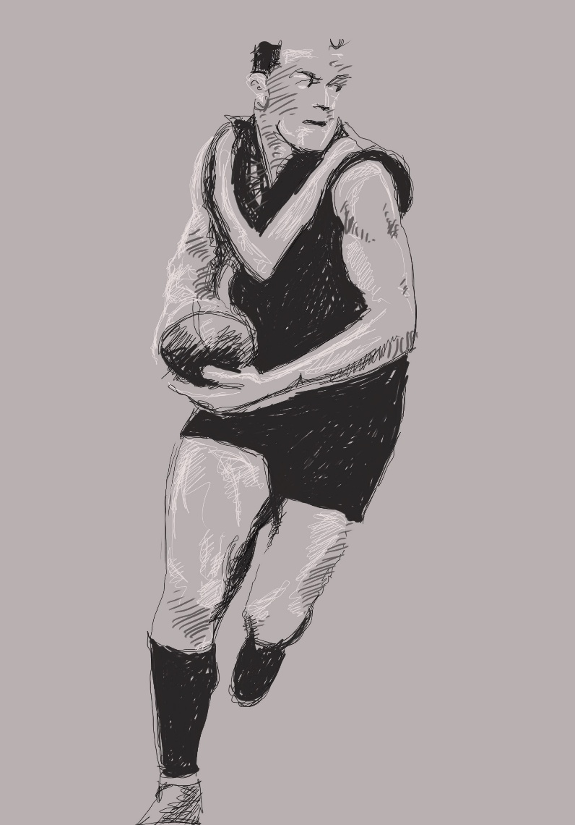
Chapter One: The Trials
Annie jostles with her opponent at the centre circle. At the tap-down, she sweeps in and takes the footy in the palm of her hand. She feints right, dodges left and bounds away. When an opponent charges at her, she handballs to Cass and keeps running. Cass takes a few strides, draws a player, then handballs back to Annie. Annie’s inside the fifty-metre line now, the goals almost in range. One of the forwards, Mags, is leading up to Annie, her opponent five metres behind. Mags had great game sense but she could be clumsy. The last time Annie fed Mags, she’d dropped the mark. Annie’s almost within kicking distance of the goals. She can kick the goal herself in a few more strides. She pictures the ball sailing through the posts, the highly impressed nods of the District team selectors.
She’ll show them what she’s made of! She bounces the ball and keeps running, feeling the grass springing beneath her feet as the white posts draw closer. Mags waves her arms, pleading for the ball. But Annie’s only thirty metres out now. She can do it, she knows she can!
Mags’s defender is leaving her; she’s running hard at Annie. Annie takes another bounce, takes three more strides, takes a last peek at the looming goal posts. She steadies, drops the ball onto her foot.

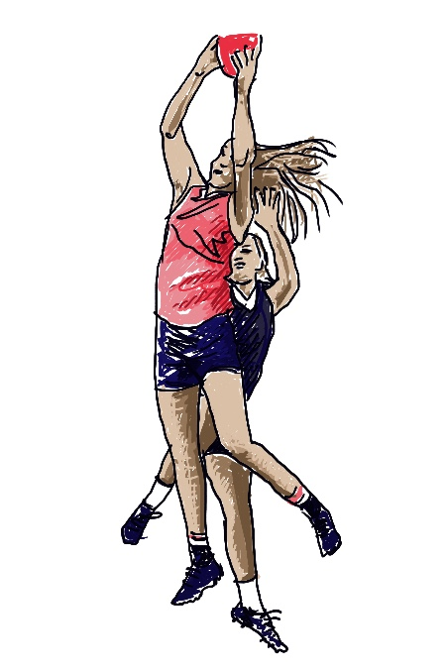
The defender tries to tackle but she’s running so hard she’s out of control. She slams into Annie – BAM! – catching her under the ribs, sending her flying. Annie arcs through the air, goal posts criss-crossing her line of sight, along with the horrified faces of Mags and the other players. The ball hits the grass, twirling hopelessly. It’s closely followed by Annie, who at first thinks it’s all kinds of funny.
The girl untangles herself from Annie, scoops up the ball and bounds away in the other direction. Annie would prefer to lie on the grass and catch her breath. But the District Team trials only come once a year – and she’s got a bit of making up to do now – so she jumps up to chase. It’s only when she plants her right arm on the grass that she feels the pain. Something is wrong; very, very wrong.
It takes a few seconds for the pain to build. At the other end of the field, the opposition kicks a goal and people whoop and cheer. At Annie’s end of the field, where she still sits, unable to get up, the pain in Annie’s arm explodes.
She screams – louder than when she was on the rollercoaster last Christmas, louder than when her twin brother Zeke used her new skateboard for an astronomy experiment.
Mags runs to her side. ‘It’s not that big a big deal, Annie,’ she says. ‘We’re still up by two. We’ll get it back.’
Tears well in Annie’s eyes, she can’t help it. ‘It’s not that,’ she manages.
‘Oh, don’t worry about what happened back there,’ says Mags. ‘You were right to go it alone. I probably would’ve muffed the goal-kick anyway – even if I’d taken the mark.’
Annie holds her right arm with her left, her face scrunched in pain. ‘Mags,’ she puffs. ‘My arm. I think it’s broken!’
*
The District Team selection trials were a big event in town. They were always in early autumn, the weather crisp and clear. Families came from all over the area, kids who were old enough hoping to be part of the lucky team that got to travel to different towns for a whole month. On selection day, they’d set up on the sidelines with picnics and Eskies. You’d have thought it was a grand final. The organisers had even brought in selectors from out of town, ever since the kerfuffle a few years back when three parent-selectors had nearly killed each other.
This was the first year Annie was old enough to try. Her first big footy test! But she’d been trying out for years inside her head. While Zeke and their mum talked about planets and stars – like they actually mattered – Annie and her dad would be kicking and hand-balling on the oval down the road named after her footy-hero grandfather. When Zeke and their mum went off at night to freeze to death on a hilltop, binoculars in hand, Annie and her dad would be tucked up on the couch watching AFL, Annie twirling a football as they analysed performances and tactics.
Her dad was having to miss the trials for work. He’d hugged Annie as he was leaving. ‘Annie Walker,’ he’d said, ‘whether you make the team or not, you’ll always be a star to me.’
What was with her family’s obsession with stars?
*
Now Annie stands holding her arm, trying not to whimper, in front of three clipboard-clutching selectors, each wearing black sunglasses so that she can’t see their eyes. She can see their mouths though. Not one of these mouths is smiling. Not one single mouth is telling her how brilliantly she was playing until her unfortunate incident.
But, worst of all, Coach Kemp’s wife, Carol – whose mouth is very large and whose voice is usually so crisp – is talking to her in a weird coochy-coo way, like Annie’s a baby. And what she’s saying just doesn’t make any sense.
‘Bad luck, Annie,’ she’s saying. ‘Your mum and brother are taking you to the hospital. There’s always next year.’
*
Zeke looks up from his astronomy book and sniggers as Annie flails at her seatbelt, trying to undo it using only her left hand.
She glares at the sling around her right arm.
‘That arm won’t be seeing any action for a good six weeks,’ a cheery long-nosed doctor told her at the hospital. ‘Good time to catch up on your homework, eh?’
Six weeks. The length of time the Inter-District Tournament lasts. The length of time her plaster cast needs to stay on. Annie had fought back the urge to jump from the hospital bed and punch that cheery doctor right on his hooter.
‘Zeke, help your sister, for goodness’ sake,’ their mum Rosie calls back from the driver’s seat. Rosie jumps out, then comes around to open Annie’s door.
‘Go on inside, love. Sorry to bring you here, but I’m so far behind with my invoicing. Zeke can find you a book to read or something.’
‘Can’t I just go home now?’
‘Don’t be a baby,’ says Zeke.
Rosie gives Zeke a stern look. ‘Annie, the doctor said we had to keep an eye on you, remember?’
Annie picks up her sports bag with her good hand. Sweat from the game has dried on her skin. It feels yucky against her still-damp playing uniform.
‘Just leave that in the car, eh?’ says Rosie.
They’re in the town’s main street, outside the shop that has been in Rosie’s family for generations. Above the door is its name embossed and painted in the façade, curlicues at either end.

‘Antiques, Curios & Memorabilia’
it reads on the top line. And below that,
‘Unknown & Unexpected in Every Nook & Cranny’
‘Can I at least bring my football inside?’ asks Annie.
Rosie rolls her eyes. ‘Oh Annie,’ she sighs. ‘I think you know the answer to that.’
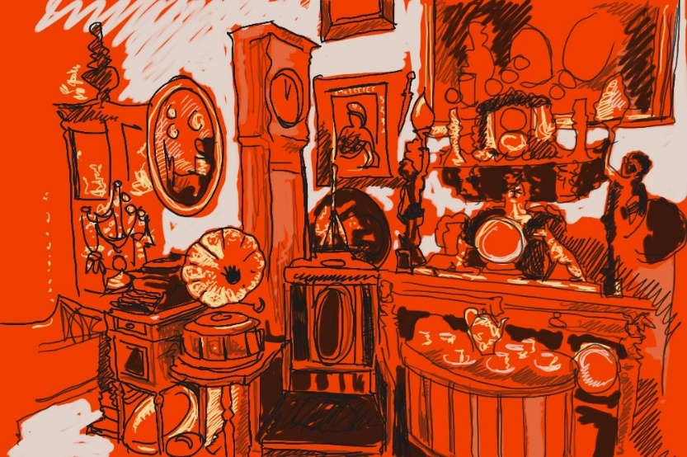
Chapter Two: Unknown and Unexpected
Annie stands in the entryway of her mother's antique store. She knows better than to walk into her mum’s shop with cleated footy boots. Her mum would have a fit.
‘Here,’ Rosie bends down and unlaces her footy boots. ‘It’s okay, sweetheart. You can have the team sign your cast.’
Annie just nods, her shoulders sagging. She’s let herself down, the Walker name down, her Pop down. How is she going to show her face? What is she going to do this season now she can’t play?
Her mum's mobile breaks through the silence; she knows it will be her dad, wanting to know how the trials went.
‘Did you want to talk to him?’
Annie shakes her head.
‘I do,’ Zeke pipes up, taking the phone. ‘Hey Dad, I’ve been studying the Scorpius Constellation…’ His voice trails off as he walks inside the shop.
Annie sighs, slipping her thongs on.
‘Give me those; I’ll take them out back, and you can wash up,’ Rosie says, following her son through the door.
Annie nods, following her mum inside, the bell ringing as she opens the door, and the dusty old smell filling her nose. To Annie, it smells of old books and furniture polish. She makes her way through the employees-only area near the cash register and past the sign that says ‘No public toilets’. At the sink she cleans herself up. Zeke has finished talking to their dad and now has his nose in a book.
‘That better be your quadratic equations textbook and not another astronomy book,’ Rosie calls out.
Zeke huffs, closes the book, and pulls his textbook toward him. He wants to be an astronomer. He’s always going on about constellations, like Hydra and Scorpius being two of eighty-eight officially documented constellations.
Annie smirks as she shuffles out of the room and into the shop. Her arm aches; the cast is uncomfortable. The overcrowded shop is filled floor to ceiling with antiques from every time period. Her mother inherited the store from Annie’s Pop and Nan.
Next to the cash register, the glass cabinet holds the Walker family memorabilia. An old leather football, signed by her pop, Trevor Walker, and his premiership team, sits in front of a framed news article about her pop’s legacy and a team picture with him front and centre, holding a trophy plaque engraved with the team name: Tigers. Next to the cabinet is a photograph of Nan and Pop in front of the store, big smiles on their faces, and her mum as a little girl. She continues her way down the line of portraits; they fade from colour to black and white.
She grips her lucky mouthguard that’s still in her pocket with her good hand.
‘I promise to make it up to you.’
Continuing along the wall are more portraits of different football players. Some are relatives, others are local players. She winces as the creaky floorboard makes its usual whine.
‘Annie, are you okay?’ Zeke yells out.
‘Yeah.’
‘You don’t sound it.’ Zeke says.
Their mother pops into existence; she was weird like that. She also seemed to have eyes in the back of her head and super hearing. ‘Annie, everything alright?’
‘Yes.’
‘Are you sure?’
‘I am, I swear. Why don’t you believe me?’
‘I do, sweetheart. I’m your mum. It’s my job to worry.’ The bell at the door rings, distracting her mum. ‘Just be careful.’
‘I will.’ Annie replies. She spies Zeke staring at the football in the case.
‘Do you think Pop was disappointed I never got into footy?’
‘Nah.’
‘I hope you're right.’
Annie pats her brother's shoulder and makes her way further into the store. She’s never really spent a lot of time here, preferring to climb trees and bike through the local bush with her friends, but she had to be home at a decent time.
She walks by the hat stand, which displays wigs and top hats. Beside it is a long canister holding all sorts of walking sticks with odd-shaped ends. A glass display on the opposite side showcases old dolls; one’s eyes seemed to follow Annie as she passes. A wardrobe that’s been there since before she could remember stands gathering dust. When she was smaller, she used to imagine it opened to another world.
A pile of paintings leans against the wall, and next to it, something larger lies covered with an old drop sheet that had once been white. Now dust clings to the fabric.
Annie walks over and pulls at the sheet, finding it heavier than she expected, and with only one arm, it’s difficult.
‘Zeke. Zeke, come here.’
‘Coming.’
‘Give me a hand,’ she says, as he stands beside her.
‘Which one, my left or right?’
‘You know what I mean.’
He helps her pull at the sheet, exposing a chalkboard. It looks used – matte black with streaks of white powder against its surface. Some used pieces of chalk sit on the wooden ledge at the bottom of the wooden frame.
The twins step back. Zeke is the first to notice faded text against the black surface.
‘I think those are names.’ He points to one side of the board. ‘I wonder what these lines are.’
‘There’s a plaque.’ Annie notices the little metal plate sitting in the lower corner against the wood. ‘Isn’t that Pop’s name?’
‘Hang on.’ Zeke scurries off. He’s not gone long before he comes back holding a framed image.
‘Be careful with that. Mum will kill us if it breaks.’
‘What are you two doing back there?’ Their mother's voice echoes down the walkway.
‘Nothing,’ they say in unison.
‘Don’t break anything,’ she yells out.
‘How does she do that?’ Annie asks.
‘Who knows.’ Zeke shrugs his shoulders.
They let out a breath as the bell at the door chimes and their mother is distracted by a customer.
Zeke places the photograph on a nearby table. ‘But look.’
Pop is standing next to the same blackboard, a big grin on his face.
Annie squeals, ‘That’s a blueprint for a game.’
‘A what?’
‘It’s a game plan that the coach puts together before the game.’
She hugs her brother in excitement.
‘Zeke’s breaks over, back to your quadratic equations, if you still aim to be an astronomer in the future.’
Annie watches as Zeke drags himself back to his study.
‘This is the answer,’ Annie whispers to herself.
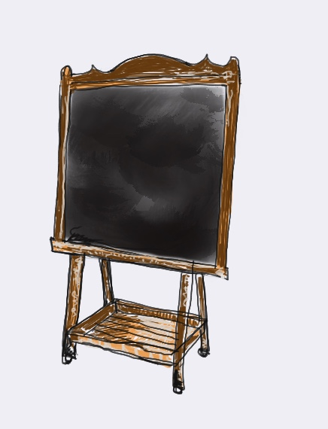
Chapter Three: Food for the Astronomer
Annie draws closer to the chalkboard at the back of the antique shop. There are several pieces of coloured chalk on the tray at the chalkboard’s base. She picks up the red one in her left hand. It is strangely warm in her fingers. She looks around. She feels the presence of her Pop as if he is watching her and encouraging her.
She draws a typical football lineup. It is hard with her left hand. She draws a player configuration: six forwards in red: three midfielders below them in blue: six defenders below them again in yellow and three ‘crumbers’ or followers randomly spaced among them in green. The team aways starts this way with their coach, but they rarely win any of their games. For some time, she has believed they needed to change, there must be a better way.
Meanwhile, at the front counter of the antique shop, their mum is giving Zeke some mathematics coaching.
‘You’re not going to be an astronomer just by looking at the sky at night,’ cajoles Mum.
‘You must be good at maths to go to university and learn everything an astronomer needs to know.’
‘Mum! I’ve got quadratic equations worked out,’ Zeke complains. ‘Can we do something else?’
‘Your hour’s not up, young man. We’ve time to do a few more, to make sure.’
Annie looks up. Her concentration is broken by Zeke’s whinging at their mum.
‘What’s so special about stars and constellations anyway?’ Annie insists. ‘You can’t do anything with stars and planets and things except look at them and get freezing cold. Besides, they never change. Boring.’
‘They are amazing,’ retorts Zeke. ‘You just have to learn to look upwards instead of always looking down at your feet and chasing a stupid leather ball around, and coming home with bruises and broken bones, and covered in mud. You could learn to recognise the constellations if you tried. They are beautiful, and they all have stories attached to them; they were described in stories by our first nations people and by the Greeks and Romans, and even before that by the Babylonians.’
‘What’s beautiful about them?’
‘Hey mum, can we take a break?’ Zeke asks. ‘Can I draw a constellation for Annie on the chalkboard to show her what I mean? The constellation of Scorpius is in the ascendant, and it is one of the most beautiful constellations in the sky at this time of year.’
‘All right, Zeke. Just a short break. Be careful with Pop’s chalkboard. He used it every day to plan his football. Meanwhile, I’ll go make some pikelets – and put honey on them, as long as you don’t smear sticky fingers on everything in the shop.’
‘Annie,’ Zeke rushes on, ‘you’ve really got to see my two favourite constellations, Hydra and Scorpius. I like Hydra as it’s the largest constellation in the sky and actually contains many hundreds of stars but just seventeen main ones. The Hydra apparently was a giant many-headed serpent. When one head was cut off, two more would grow back in its place, and the word describes problems that are hard to defeat because new difficulties appear as fast as old ones are solved.’
‘Sounds like our football team trying to win and always being unsuccessful,’ mutters Annie.
‘Ha, ha,’ Zeke laughs. ‘I’ll show you the pattern of Hydra’s seventeen main stars first. It’s like this.’
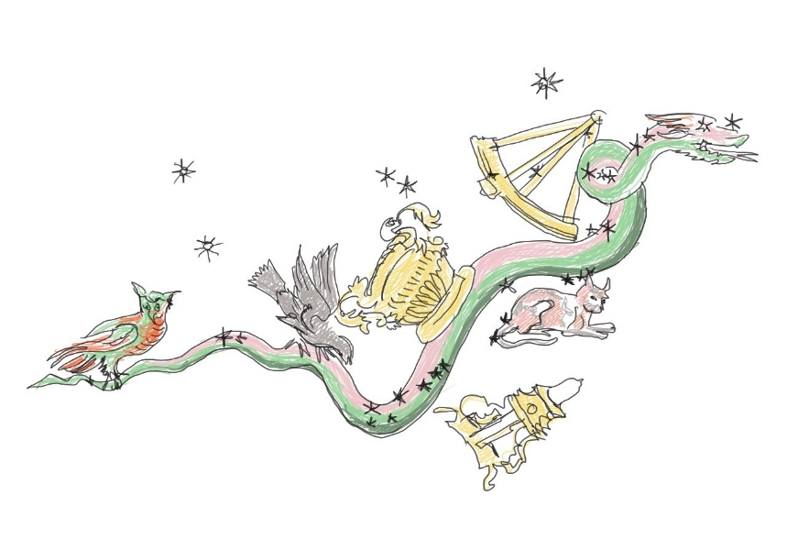
Zeke picks out a pink chalk, the colour of Annie’s team’s jerseys – Very suitable, he thinks – and draws an array of seventeen stars on the chalkboard above Annie’s game plan. It stretches like a snake across the board with six at the head, six in the middle and five at the bottom.
‘But for sheer majesty and beauty, I prefer the second one.’ Zeke draws another pattern of stars, the constellation of Scorpius, on the chalkboard.
‘Look Annie, this constellation looks like a scorpion. That’s how it got its name. Look! It has a great star-filled head in the middle of the milky way – that’s our galaxy – and curves its tail downwards to two bright stars which is the scorpion’s sting. If you look carefully, you can count its eighteen stars. I have drawn them all here – have a count.’
Annie looks at what Zeke has drawn. Eighteen stars! That’s the number of players in a football team. We could have an AFL club called Scorpio. Eighteen star players! It could be the name of our club.
As she looks, the chalk marks on the board seem to move; some vanish and reappear in another place in a different arrangement. Above the head of Scorpius, stars appear to spell out a word - ‘Pop’. The eighteen stars twist and turn and move into different patterns on the board. Annie freezes with astonishment. It must be Pop! He must be talking to me through this chalkboard, the chalkboard he used all his life.
‘Time for more maths, Zeke,’ says their mother, appearing from the kitchen
‘Not more quadratics, Mum,’ moans Zeke.
‘Not exactly, but here’s a puzzle - what do you get if you add one cup of self-raising flour, two tablespoons of caster sugar, one egg, three-quarters of a cup of milk, and butter? ‘Yes, we’ll do a few more until you’re completely comfortable with them. Back to work, young man.’
Zeke groans but helps himself to two pikelets. Annie does not pay any attention to either of them. She is looking at the cluster of green dots at the bottom of the chalkboard. They are arrayed now below the red, blue and yellow dots she had drawn preciously. The new ones are arranged in arcs of six light green, six dark green, and six medium green – defenders, forwards and midfielders. They look like two teams lined up to play, two different configurations, hers and Pop’s.
Annie feels her pop’s presence again, projecting his years of experience of football across two generations. She instantly recognises the value of this different configuration of players, his configuration; the strength of the midfielders moving between defence and attack, a configuration that can win their team future matches. She feels the urge to get back onto the field but realises she will not be playing for a while with one arm out of action. Maybe she can persuade the coach to make the changes for the next game, take the ideas to the training session, tell the coach that it might have been the winning strategy used by her famous Pop years ago.
She takes a photo of the stars with her phone and the game plans on the chalkboard and makes up her mind to discuss this idea immediately with Coach.

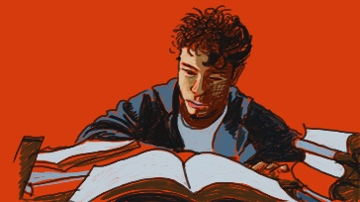
Chapter Four: Scorpius Fails
The next morning Annie is woken by a sharp pain, having rolled onto her injured wrist whilst she slept. Her arm had looked like a pink overinflated sausage yesterday before they placed it into the cast, and now the contained skin was itching like blazes; the sensation making her stomach sink. She lets out a deep sigh as she painfully recalls the clumsy district competition game and her failed chance to make this year’s team selection. She has let down her family legacy; there will be no Walker on the team. Her dream of being the first girl in the family to make it into an elite league is a bust.
Then the shadows in her room retreat before a rogue wave of excitement, hitting her like the jolt of static electricity that happened whenever she wore her favourite scarf and tried to touch a metal doorknob. The magic of the chalkboard from yesterday returned! Zeke had been drawing star configurations over her messily drawn game plans when the chalkboard had started to alter their plans. It had been Pop encouraging her football dream and his excitement about the plays they were working on. With Zeke’s nerdy star maps and her grandfather’s football experience, they now have a play that is sure to thump their District rivals The Wombats on the field: Scorpius!
Annie leaps from bed, snatching up a pair of sport shorts to single handedly hop into, following it with a shirt that isn’t too dirty. She is out of her room within the same minute, fully dressed and sporting only a small tear on the collar of her jumper; payment for her one-handed haste to dress. She streaks through the kitchen, snatching a piece of Vegemite toast from her mother’s slack fingers as she runs for the front door.
‘Where are you off to, little cyclone?’ Rosie sings.
‘Have to get to football practice,’ Annie shouts over her shoulder right before the door closes, completely missing her confused mother’s query,
‘But you didn’t make the team!’
Annie makes it to the Walker training field out of breath and sweaty. Her wrist throbs madly from the pell-mell sprint she has forced for five blocks and she is now paying for the fact that she has left her sling on her bedside table.
‘C-c-coach,’ Annie puffs weakly at the solid man standing tall with a clipboard and scruffy beard on the sidelines. Coach is a big guy whose once athletic body has slightly gone to seed, by way of an ever-expanding waist and a tangle of encroaching grey leaching into his beard. He looks away from the mess of girls moving their cleated feet in blurring speed as they zigzag between colourful cones. Coach motions her over to stand next to him and she feels an odd sense of home settling into her bones as she places her shoes next to the painted boundary line.
‘How’s the arm Annie?’
‘Still attached,’ Annie responds with a grin. Coach smiles back, crow’s feet appearing at the corners of his eyes.
‘That’s a Walker answer if I’ve ever heard one.’ Annie’s chest swells with pride at the compliment and she finds the courage to pull out her phone and present Coach with the picture of the game strategy she had worked on with Zeke and Pop’s chalkboard yesterday.
‘What’s that you have there?’
‘The answer to Saturday’s game,’ Annie replies confidently. Coach blinks in surprise before accepting the phone; bringing it closer to a pair of ageing eyes that might not be as sharp as they once were, but he isn’t ready to admit it. He silently squints at the screen, for what feels like a year to poor Annie’s thrumming heart, before looking back to her.
‘It’s got legs, Little Walker; seems Trev wasn’t the only one in the family with talent. Let’s give it a shot.’
Annie’s feet feel like they are floating off the grass as Coach’s words meld with the shrill sound of the whistle to gather the red-faced sweaty players from their drills.
‘Listen up, Tigers,’ Coach booms at the chattering group, ‘we have a play we are going to run. It’s called…’ Coach looks to Annie, who clears her throat against the flutter of nerves created by nineteen pairs of eyes suddenly laser focused on her.
‘Scorpius,’ she manages to say without stuttering. The name sweeps through the playing group and many voices start talking all at once.
‘But she’s not on the team…’
‘Scorpius what?’
‘Think there’s a yoga move called…’
‘Emma, you drongo, why would it be a yoga pose!’
‘Mags, shut up or I’ll…’
‘If you all can it and listen to Annie you’ll find out,’ thunders Coach.
Annie is hit with the inexplicable feeling that whatever comes next will make or break her fledgling dream of becoming a legendary footy player like Pop; her nerves now abruptly threaten to steal her ability to formulate words. She swallows to relieve her suddenly parched mouth, before motioning for everyone to huddle around as Coach hands her his clipboard and pen. She suddenly finds herself sitting in the assistant coach’s role.
‘We need seventeen players involved, one of our wings - that can be you, Emma - will be a dummy to draw an opposition player but won’t be involved in the actual play.’ Once she reassures Emma she wasn’t calling her a dummy but explaining her role, Annie starts drawing and issuing the same astrological titles Zeke had painstakingly battered her over the head with to the remaining players.
She puts her best friend Mags at the heart of the Scorpius constellation, with their two strongest goal kickers in the final Scorpion Sting of the tail, representing the stars Lesath and Shaula respectively.
In no time Coach is nodding and the team is scattering to their assigned positions on the field. Annie’s fingernails begin cutting into her palms as her hands squeeze into tight fists of nerves. The ball is kicked in from the defensive goal end towards Cass and another star at the head of the Scorpion: Graffias. The front two claws of the Scorpius curl together as the six players close in, the ball moving smoothly through the defensive fifty and completing the body of the constellation. The ball enters the midfield with an effortless ease that unfolds in exactly the way Annie, Zeke, and Pop’s scribbling on the chalkboard had promised.
They make it to the to the Scorpion’s tail, ready for the sting when suddenly it all just falls apart.
The mid-field transition into the offensive fifty is abruptly filled with a frenzy of confusion. The ball slips past hands that aren’t there, players lose their feet at the critical collapse inwards of curling tail and the two full-forwards spearheading the final movement are sent colliding directly into one another, in what looks to be a painful attempted melding of foreheads.
The end result is one twisted ankle, one bruised bum, five players needing a deep cleaning wash to remove the sheer amount of mud on their guernseys and the two full-forwards being sent to the nurse’s office to check for concussion.
Annie’s feet are no longer floating. She feels as if gravity is pressing her down into something resembling one of Mum’s pikelets. She has wasted everyone’s time and let the team down. The magic she was feeling when she had drawn up Scorpius with Zeke on Pop’s chalkboard died, right then and there, on that muddy field. Adding to her humiliation, she feels tears starting to well in her eyes as Coach turns to look at her. Her strategy has failed, but she certainly isn’t going to compound that by crying in front of a bunch of her friends.
‘Annie,’ Coach starts to say in a voice that was softer than she believed possible for the big bear of a man, but she is already backing away, shaking her head, not wanting to hear his disappointment or worse risk having him ask her to leave.
‘Sorry Coach, I- I’m sorry.’ She turns away from the field and starts walking. When her feet leave the comforting bounce of grass and meet with the unforgiving concrete she finds her pace slowing even further. Her sneakers feel like they are dipped into rapid-dry concrete as she drags herself down the street in the direction of Antiques, Curios and Memorabilia.
This is the second test she has failed in two days and even worse, she now has to go and let her family team know that it has all fallen apart.
Chapter Five: The Stars Align
Annie comes back to the shop, dragging her feet and slumping herself into the comfy chair beside the counter. She pulls the elastic out of her hair and wraps it around her drink bottle, then slowly takes a sip. How she hates feeling like this, stuck inside the shop amongst all the old things, with a sore arm. Really, she’d much rather be out on the field, training or playing, or just running. Feeling the grass, the sun, and the breeze. Anything but here with a bung arm and nothing to do. Trying to do some coaching would have been a good way to get her out of the shop. It would have worked too if Annie hadn’t sucked at being a coach. Not like Zeke, successful at anything he tried. She looks across at him, poring over another one of those enormous books. They were pretty, all the pictures of the stars, but she couldn’t handle all the maths he seemed to study.
Looking up from his desk, Zeke sees his sister in one of her slumps. He recognises the pose, the one she puts on when she can’t cope, when something has gone wrong and she thinks the world is against her. Now, though he can understand her discomfort, out of action from her beloved football, she is like a bird trapped in a cage in this shop. He often marvels at how different he and Annie are; she so intent on being a footballer, loving the outdoors and everything sporty. Whereas he loves the smells and secrets of the shop, the mystery of numbers, and only really enjoys being outdoors at nighttime to see the stars. Today’s mood must be because the attempt at training didn’t go well.
‘So, not a success then?’ he asks.
‘Hmph, very, very far from a success,’ says Annie, ‘a complete and utter failure and a complete and utter embarrassment.’
‘Surely it couldn’t have been that bad! What went wrong? I thought we’d worked the play through. Shall we look again?’
Making their way across the cluttered room, they stand in front of the chalkboard. Mum had moved it to be next to the trophy cabinet to give Annie some inspiration, seeing all her famous football relatives. The Walker Family. But now, looking at them all looking at her, Annie just feels like a failure.
Zeke looks at the board and sees it's empty again. No sign of their play remains. He realises he needs to record anything they draw, as it disappears and reappears at any old time.
He looks up at the photos of his grandparents. ‘Come on guys, give us something!’
The twins both look at the board expectantly, but nothing happens. Annie groans. Zeke looks at her, then looks at the board again. He gives it a shake.
Suddenly, writing appears across the board.
In my day, if there was a hitch we just got back up and got on with it! None of this moping around! We didn’t make mistakes – we made corrections! Come on girl, own it and move on.
Oh, you old codger, don’t be so harsh! But truly my darlings, if I had a chance to play football I would do it no matter what – nothing would have stopped me, girls just weren’t allowed!
Ziggy Stardust, get that star map of yours back up – you just missed some stars.
Orphan Annie, stop feeling sorry for yourself and put your play over the top, you missed out some key players.
Annie and Zeke look at each other, then Zeke gets the chalk and writes out the constellation again. Scorpius – eighteen stars, eighteen players. Carefully, Annie covers it with her play, replacing the stars with her players.
They stand back and look at the board again. It had looked good; the players lined up with the stars; the play ran through just like the constellation. So, what had happened? She knew her players were good; they were keen to have her as their coach, so had followed her instructions carefully. They had been as disappointed as she had been when they had lost the game. She felt she’d let them down, they felt they had let her down.

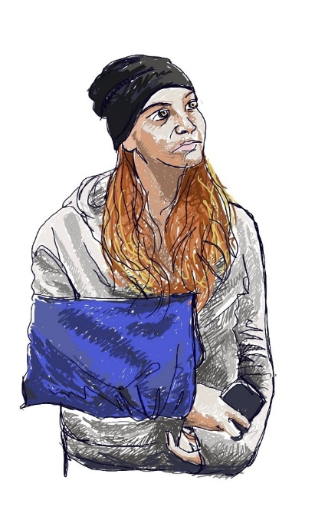

Suddenly, with a bright realisation, the mistake glares at them. Zeke says, ‘Oh Annie, we used Hydra not Scorpius. We didn’t have enough players!’
Annie realises that by taking the wing out of play too early, she’d allowed the opposition forwards too much space.
‘Zeke, I think this would work!’ Annie grabs his arm excitedly.
‘But how will I get the team to trust me again?’ Annie’s shoulders slump, and she slouches on the floor, looking miserable again.
Zeke takes a photo of the chalkboard quickly before it disappears. Sure enough, the board wipes clean, and some new writing appears.
‘Now now Annie, you always were a ‘woe is me’ child, that’s why we called you Orphan Annie. Get on your phone and twiddle your fingers, and rally the troops – that’s what we would have done!’
Chapter Six: TigerChat
She pulls her phone from her pocket and opens the Tigers’ group chat.
The bright light from the screen startles her in the dim shop.
Mum calls from the other room, ‘Are you okay?’ but Annie doesn’t answer.
‘Mum, she’s alright,’ says Zeke.
‘Shut up!’ Annie yells.
Silence. Annie stares at her phone. She knows she has been rude, but she feels too frustrated to care.
She opens the group chat and starts typing.
Annie: Guess what? I know what we can do.
Mags: I hope so because we need to win.
Amelia: At this point, we need anything to help.
Annie: It was the wrong constellation.
Emma: What?
Mia: WHAT?!
Annie: In the antique shop, we have my Pop’s old chalkboard. Pop used to use it when he coached footy.
Amelia: No way!
Charlotte: I didn’t know that.
Annie thinks back to the drawing of the game plan Zeke and her did earlier.
Annie: Zeke drew the Hydra and Scorpius constellation on the chalkboard, but I used the wrong constellation – I ran Hydra when I should’ve used Scorpius!
No-one answers for a moment.
Annie: We HAVE to play Scorpius.
Emma: Uh...
Annie: Scorpius is a constellation with 18 stars, according to Zeke.
Emma: I don’t get it.
Mags replies almost straight away.
Mags: 18 stars = 18 players.
Emma: What? I still don’t get it.
Annie shakes her head.
Sometimes she can’t believe how slow Emma can be.
She starts typing again.
Annie: Well, we have 18 players and if we follow the game plan of the Scorpius constellation, I believe we will win!
For a few seconds, the group chat goes completely quiet.
Annie holds her breath.
Then —
Mags: Well, it sounds like a plan.
Amelia: I’m in.
Lucy: I’m in.
Emma: I’m in.
Another message appears.
Cass: We’re all in!
Annie's face lights up.
Annie: YES! Let’s meet up for a secret practice!
She puts her phone down and looks at the chalkboard. For the first time that day, she is smiling. Then she adds the players' names around the constellation.
‘That's a pretty good grin,’ Zeke says.
Annie jumps.
She hadn't heard him walk into the room.
‘What’s up?’ he asks.
‘Nothing.’
Zeke folds his arms.
‘Really? Because that doesn't look like a nothing grin.’
Annie tries to hide her smile.
‘Something has happened.’
‘I knew it.’
Annie turns the chalkboard around so Zeke can see.
‘Guess what? I convinced the whole team to play the Scorpius constellation.’
Zeke stares at the board. ‘But I thought you already played Scorpius.’
‘We thought we did, but it was Hydra.’
Zeke walks closer to the board. His eyes follow the eighteen stars. ‘Scorpius has eighteen stars, right?’
‘Right.’
‘And you have eighteen players?’
‘Exactly.’
Zeke looks at Annie, then looks back at the board. ‘Of course.’
Annie laughs. ‘You're the one who told us about the constellations!’
She steps back and looks at the chalkboard. The game plan suddenly seems different. The eighteen players aren't just names anymore.
They are stars.
Each player has a position.
Each position has a purpose.
And if they work together, just like the stars in the constellation, maybe they can finally win.
‘I can't wait to play tomorrow,’ Annie says.
Zeke smiles. ‘Neither can I.’
Just then, Mum appears in the doorway. ‘It's time to go home.’
Annie looks at the clock. She hadn't realised how late it had become. She and Zeke quickly pack everything away. Annie carefully puts the chalk back in its box before taking one last look at the board.
Eighteen stars.
Eighteen players.
One game plan.
She hopes it is enough.
They lock up the antique shop and start walking home just before sunset.
The air has cooled, and a gentle breeze moves through the trees.
The last light of the day stretches across the sky, turning the clouds shades of orange, pink and purple.
High above them, red-tailed black cockatoos move from tree to tree, their calls echoing through the bush as they search for gum nuts in the jarrah trees.
Annie slows down to listen.
She has always loved the sound of the cockatoos.
Tonight, though, everything seems different.
She looks up at the sky.
The first stars are beginning to appear.
One.
Then another.
Then another.
Annie counts them silently.
She smiles.
Maybe there really is something about the stars.
Mum notices. ‘What are you smiling about?’
Annie looks at her. ‘Nothing.’
Mum laughs. ‘That’s twice today you've said that.’
Annie kicks a small stone along the path.
Mum waits. ‘So,’ she says, ‘how was training?’
Annie sighs. ‘It didn’t go well.’
Mum gives her a sympathetic look. ‘But?’
Annie smiles. ‘But I know why.’
‘Really?’
‘Yeah. It was the wrong constellation.’
Mum stops walking. ‘The wrong constellation?’
Annie nods seriously. ‘I've convinced the whole team to play Scorpius tomorrow.’
Mum looks at Annie for a moment before glancing up at the evening sky. ‘And why Scorpius?’
‘Because it has eighteen stars.’
Mum smiles, ‘Eighteen players?’
‘Exactly.’
Mum nods thoughtfully. ‘Well then,’ she says, ‘I suppose the stars have aligned.’
Annie laughs. ‘Exactly!’
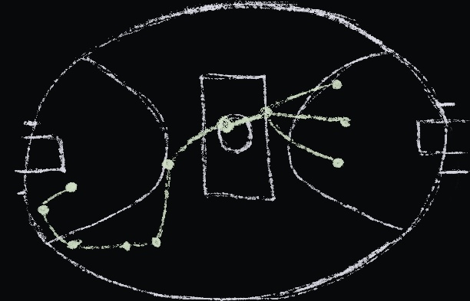
Chapter Seven: Game Day
Annie awakes, stretching and yawning, looking out at a sky full of crisp, white clouds. It is a fine autumn morning, and the leaves on the trees in her front yard are a riot of reds and yellows, but she notices nothing… It’s game day! The big event is finally here, and all of her hard work – their hard work, for it had truly been a team effort – is about to pay off.
Annie pulls on her guernsey and shorts, then hurtles down the stairs, yelling for Zeke and Mum. Mum is waiting at the bottom of the stairs, toast in hand. Annie snatches the toast out of Mum’s hand – peanut butter and Vegemite, brilliant! – and scoffs it down.
Zeke arrives at last, munching on the last of his breakfast, and in a melee of bags, towels and water bottles, with plenty of:
‘Have you got…?’
‘Don’t forget…’, and
‘Watch out!’, they are out the door and piling into Mum’s faithful old car.
Annie messages TigerChat throughout the drive, checking that everyone is still on board and remembers the play. Some are more nervous than others, and some have slept better than others, but every player is with her.
They get to the ground, and Annie runs to the clubroom while Zeke and Mum park and get to their seats. Suddenly, Annie panics. Dropping her bag, she pulls everything out, frantically looking for her lucky mouthguard. She knows it’s not rational to have lucky things – Zeke has pointed this out plenty of times – and it’s even less rational to hang onto it when she won’t be on the field, but she doesn’t care. Anyway, what is rational these days, what with haunted chalkboards and stars aligning all over the place! She finds the mouthguard, sighs with relief as she pops it in her pocket, and takes her seat for Coach’s pre-game pep talk.
Coach is in fine form today, saying all the usual stuff about all the usual plays. Annie risks a quick look at each of her team-mates, and stops herself from grinning when they all give a sly wink or a barely noticeable nod. This is it, they are really going to do it!
Thank you, Pop and Nan, thank you, Zeke, she thinks, and feels warm inside.
She is the grand-daughter of Trevor Walker, Walker the Stalker, who never let an opponent get the ball unchallenged, and today her team will win! She’s doing it for Nan, who never got to fulfil her dream; she’s doing it for…
‘ANNIE, EARTH TO ANNIE!’ Coach yells, and Annie’s attention snaps back into the clubroom. Her friends laugh, some nervously.
‘Time to go’, Coach says, with a firm but encouraging look around at the team.
‘Annie,’ he growls awkwardly, ‘you can stand with me.’
The team forms a circle and put their hands atop one another, saying the team chant –
‘OO! AH! OO, OO, AH!’ finishing with a massive roar:
‘Gooooo, Tigers - RRROWR!’
As the team runs out onto the field, Annie stands near Coach, spotting Zeke and Mum across the oval. They wave and yell like the loveable idiots they are:
‘Go, Tigers! ‘Get ’em, Tigers!’
‘Stalk ’em, catch ’em, ruthlessly dispatch ’em!’
The game starts much like any game, and the team spend the first quarter running hard against the Wombats, who – much like real wombats – are faster and smarter than they look. Coach is calling the plays, and the team do them perfectly, but they just can’t get ahead of the stocky Wombats, who stop them in their tracks every time they try to push down the field.
By half time, Coach is looking worried; by three-quarter time, he is sweating and pacing up and down the sidelines. Looking on from the grandstand, Mum comments to Zeke that Coach actually seems to be losing the last of his hair, but Zeke doesn’t hear… he is in the twilight zone, and the stars are aligning…
The siren sounds, heralding the final quarter. For a time, the Wombats and the Tigers battle it out, point for point, goal for goal, but the Wombats start to creep ahead, until, with only seconds left on the clock, the Wombats kick a goal that puts them five points ahead.
The ball comes back to the middle, and the umpire folds himself double – ‘OOF!’ – to bounce the ball high into the air. For a moment, time stands still… and then Zeke and Annie both hear it – the sound of another siren, coming from somewhere – or somewhen – far away. The other Tigers feel something in the air, and they all look to Annie. ‘Scorpius,’ she mouths, and waves her arm like scorpion pincers. The Tigers clack their pincers back at her, and Coach looks like he may be going to faint.
In the stands, Zeke begins to mutter, ‘Scorpius, Scorpius’.
Time starts moving again, and the Tigers snap into action.
‘Graffias!’ Cass wins the tap from the centre bounce, and flicks it down to a team-mate who gives the ball an almighty kick, sending it sailing down the field as the Tigers scurry into their Scorpius positions.
‘Antares, heads up!’
An awaiting Tiger – once she was Mags, now she is Antares, the red supergiant – runs around a mob of Wombats to take the mark, just outside the fifty. Things slow down for a second as she looks for an opening, and then the Scorpion’s sting appears.
Annie sees it first, and calls out, ‘Lesath! Kick it to Lesath!’
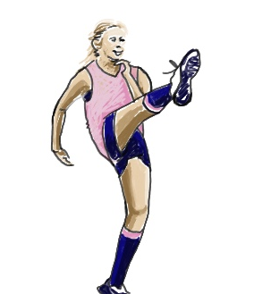
Antares snaps the ball in a low, hard pass that finds its target perfectly.
Lesath – who until yesterday only knew herself as Lucy – takes her time with the setup. She pulls her socks up, straightens her ponytail, licks a finger and tests the wind. She takes a slow step forward, then another, does a little jog on the spot, then takes four big steps in quick succession, and THUMPS the Sherrin towards goal.
It’s not a great kick, in fact it’s a shocker, but it’s enough. A wily Wombat spins away from their defender in an attempt to touch the ball and save the win, but the other half of the Scorpius sting – Shaula, formerly known as Sharon – won’t be shaken off, and bumps the Wombat just enough to let the ball sail through the big sticks for six points as the final siren sounds.
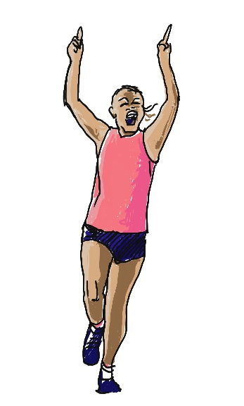
The home crowd are on their feet, but Annie holds her breath, almost frightened to believe what she’s seeing and hearing. Then the noise of the crowd rushes in, and she realises that the team is bolting down the field towards her, a streak of Tigers screaming, ‘SHAUUUULA! SCORPIUS! SCORPIUS!’
Even the football commentator, who fancies himself the next Dennis Commetti, forgets himself for a minute and joins in, yelling, ‘Scorpius! Scorpius! Go, Tigers!’
Coach runs up to Annie, and for a second she is worried, but he simply takes her good hand in his big paw, and says with a choked-up voice, ‘I don’t know what you did to Scorpius, Annie – you have to tell me later – but your grandfather would be proud of you. Well done, new Assistant Coach Walker, the District is lucky to have you.’
In the crowd, Zeke is grinning, and trying to breathe as Mum gives one of her patented rib-crushing hugs, tears streaming down her face.
‘I can’t wait to Facetime Dad, Zekey!’
And back at the shop, where all is quiet, a small eddy of dust swirls around Pop’s chalkboard, a faraway siren sounds, and a gentle scratching of chalk can be heard, as words slowly appear:
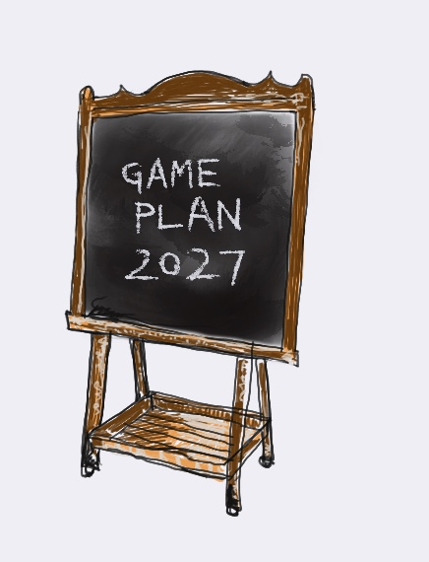

Stars of the Scorpius constellation:

Dschubba – marks the scorpion's forehead
Graffias (also called Acrab) – part of the scorpion’s head
Jabbah – a multiple-star system near the head
Fang – part of the scorpion's body
Girtab – a bright star in the tail region
Antares – the bright red heart of the scorpion; the brightest star in Scorpius
Alniyat – a pair of stars near Antares
Sargas – a bright star in the tail
Shaula – one of the stars marking the scorpion's stinger
Lesath – the other stinger star
A simple way to recognize Scorpio in the sky is to look for Antares (the red heart), Dschubba and Graffias (the head/claws), a curved chain of stars forming the body and tail, and Shaula and Lesath (the stinger at the end of the tail).

Sources: en.wikipedia.org, stargazr.io

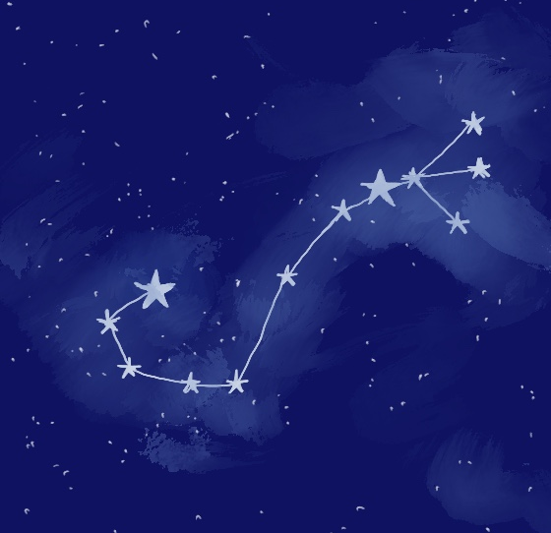
Sagittarius
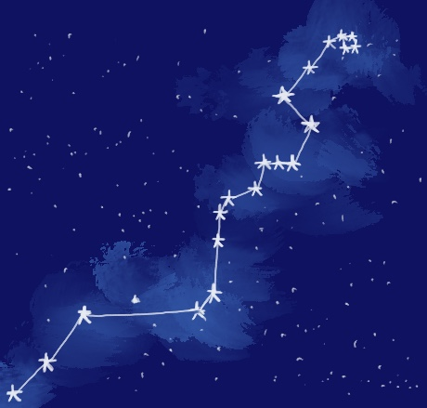
Hydra

Meet the team - Furphies at Collins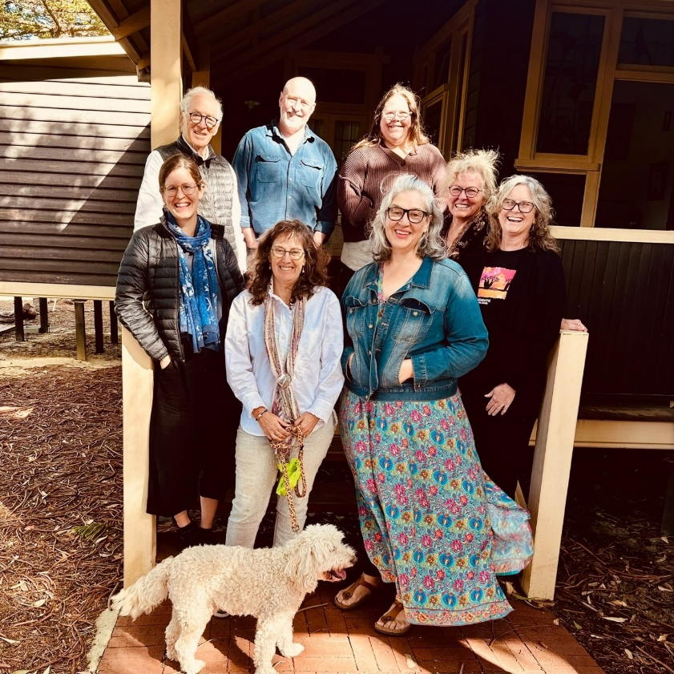

Rear:
Chris Oakeley, Ricky Arnold, Janine Fisher-Lee
Front:
Amy Bell, Bronwen Channon, Rosalyn Fairless, Jen Banyard, Danette Isgar
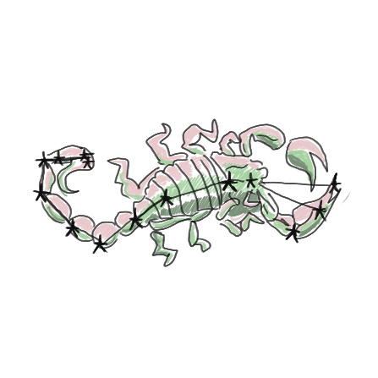

When Annie breaks her arm, failing the most important football selections of her life, she finds herself stuck in the family antique shop with her nerdy, star-loving brother, Zeke, for company. They combine forces – her knowledge of football, Zeke’s knowledge of astronomy, and some paranormal help from their grandparents, communicating through a magical chalkboard. A mix-up of constellations, a chalkboard that acts like a magic eightball, and the ego of past heroes – what could possibly go wrong?

Recommended for readers 10 -16 years of age.

Wow – I wish I’d thought of coaching like that! Star quality!
Malcolm Blight
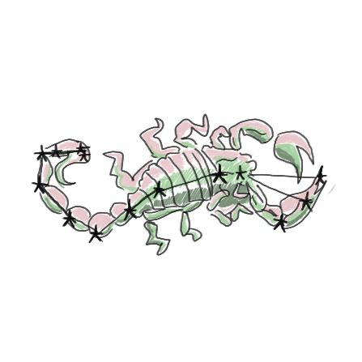
Reach for the stars – a true tale of adventure and achievement.
Stars for Aspiring Astronomers
When you reach for the stars, it's good to know you have a supportive team.
Your Stars Today
Astronomy? Oh I thought you said astrology … still a good read, and I’m glad the girl was a winner in the end.
Lady Gaga
Most interesting chalkboard that’s come to our experts' attention in years.
Antiques Roadshow
A delightful skirmish of star-struck magic and football mayhem. Astronomy and Sports Weekly

